
Anjuman-I-Islam’s

M. H. SABOO SIDDIK COLLEGE OF ENGINEERING
8, Saboo Saddik Polytechnic Road, Byculla, Mumbai, Maharashtra 400008

DEPARTMENT OF INFORMATION TECHNOLOGY

Mini Project ITL605 DS LAB

Title of the Project

Drowsy Driver Detection

Supervisor/Guide

PROF.FARZANA KHAN

REV - 2019 ‘C’ Scheme

University of Mumbai

Academic Year (2024 -25)

GROUP MEMBERS

STUDENT NAME | ENROLLMENT NO.
YAMIN KHAN | 242464
ABDURRAHMAN QURESHI | 242466
SHAIKH RUMAAN | 242469
SHAIKH SAMEER | 242471

TABLE OF CONTENT

Sr.No | Content | Page No
1 | Problem Definition | 1
2 | System Architecture | 2
3 | Tech Stack | 3
4 | Results And Visualizations | 4
5 | Conclusion or Business Insights | 7

PROBLEM DEFINITION

Driver drowsiness is a major cause of road accidents worldwide. Fatigue reduces reaction time, awareness, and decision-making ability, which can lead to serious or fatal crashes. Traditional methods like self-awareness or manual monitoring are unreliable.

The problem is to develop a real-time system that can automatically detect whether a driver is active, drowsy, or sleeping using a webcam and alert them before an accident occurs.

This system aims to:
- Monitor the driver continuously
- Detect eye closure and blinking patterns
- Classify driver state into Active, Drowsy, or Sleeping
- Provide visual feedback (and can be extended to alarms)

SYSTEM ARCHITECTURE

The system follows a computer vision pipeline: Step-by-step Flow:

Input Layer
  - Webcam captures real-time video frames using OpenCV

Preprocessing
  - Convert frame to grayscale for faster processing

Face Detection
  - Use dlib.get_frontal_face_detector() to detect face region

Facial Landmark Detection
  - Use pre-trained model shape_predictor_68_face_landmarks.dat
  - Extract 68 facial points (eyes, nose, mouth, etc.)

Eye Detection & Feature Extraction
  - Focus on eye landmarks (points 36–47)
  - Compute distances between vertical and horizontal eye points

Eye Aspect Ratio (EAR) Calculation
  - EAR determines whether the eye is open or closed
  - Based on ratio:
    - High → Eye open
    - Medium → Drowsy
    - Low → Closed

State Classification Logic
  - Counters used:
    - sleep
    - drowsy
    - active
  - Based on thresholds:
    - Active :)
    - Drowsy !
    - SLEEPING !!!

- Output Layer
  - Display status on screen using OpenCV
  - Show:
    - Face bounding box
    - Landmark points
    - Driver state text

TECH STACK

Programming Language :
  - Python

Libraries Used :
- OpenCV (cv2)
  - Video capture
  - Image processing
  - Display output

NumPy (numpy)
  - Mathematical operations (distance calculation)

dlib
  - Face detection
  - Facial landmark detection

imutils
  - Simplifies landmark handling (face_utils)

Model Used :
  - shape_predictor_68_face_landmarks.dat
    - Pre-trained facial landmark detection model

Hardware Requirements
  - Webcam
  - Computer/Laptop (real-time processing)

RESULTS AND VISUALIZATION
Code :

import cv2
import numpy as np
import dlib
from imutils import face_utils

cap = cv2.VideoCapture(0)
detector = dlib.get_frontal_face_detector()
predictor = dlib.shape_predictor("shape_predictor_68_face_landmarks.dat")
sleep = 0
drowsy = 0
active = 0
status = ""
color = (0, 0, 0)
face_frame = None

def compute(ptA, ptB):
dist = np.linalg.norm(ptA - ptB)
return dist

def blinked(a, b, c, d, e, f):
up = compute(b, d) + compute(c, e)
down = compute(a, f)
ratio = up / (2.0 * down)
if ratio > 0.25:
return 2
elif ratio > 0.21 and ratio <= 0.25:
return 1
else:
return 0

while True:
_, frame = cap.read()
gray = cv2.cvtColor(frame, cv2.COLOR_BGR2GRAY)
faces = detector(gray)
face_frame = frame.copy()
for face in faces:
x1 = face.left()
y1 = face.top()
x2 = face.right()
y2 = face.bottom()
cv2.rectangle(face_frame, (x1, y1), (x2, y2), (0, 255, 0), 2)
landmarks = predictor(gray, face)
landmarks = face_utils.shape_to_np(landmarks)
left_blink = blinked(landmarks[36], landmarks[37],
landmarks[38], landmarks[41], landmarks[40], landmarks[39])
right_blink = blinked(landmarks[42], landmarks[43],
landmarks[44], landmarks[47], landmarks[46], landmarks[45])
if left_blink == 0 or right_blink == 0:
sleep += 1
drowsy = 0
active = 0
if sleep > 6:
status = "SLEEPING !!!"
color = (255, 0, 0)
elif left_blink == 1 or right_blink == 1:
sleep = 0
active = 0
drowsy += 1
if drowsy > 6:
status = "Drowsy !"
color = (0, 0, 255)
else:
drowsy = 0
sleep = 0
active += 1
if active > 6:
status = "Active :)"
color = (0, 255, 0)
cv2.putText(frame, status, (100, 100),
cv2.FONT_HERSHEY_SIMPLEX, 1.2, color, 3)
for n in range(0, 68):
(x, y) = landmarks[n]
cv2.circle(face_frame, (x, y), 1, (255, 255, 255), -1)
cv2.imshow("Frame", frame)
if face_frame is not None:
cv2.imshow("Result of detector", face_frame)
key = cv2.waitKey(1)
if key == 27:
break

Output :

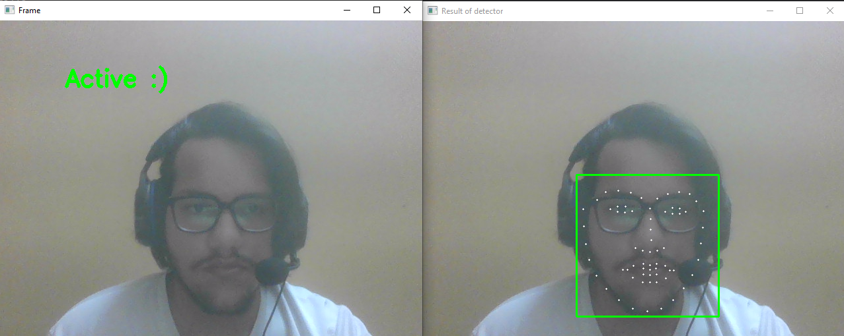

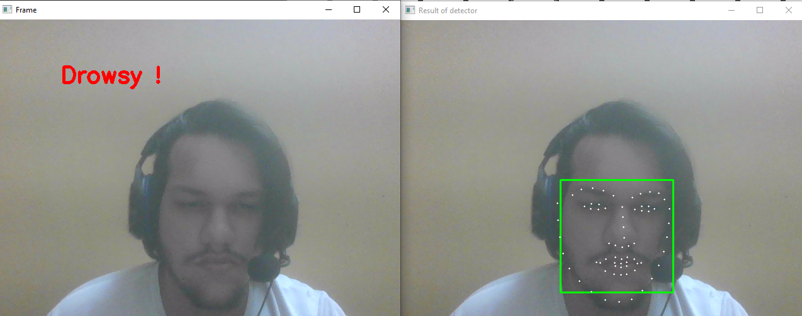

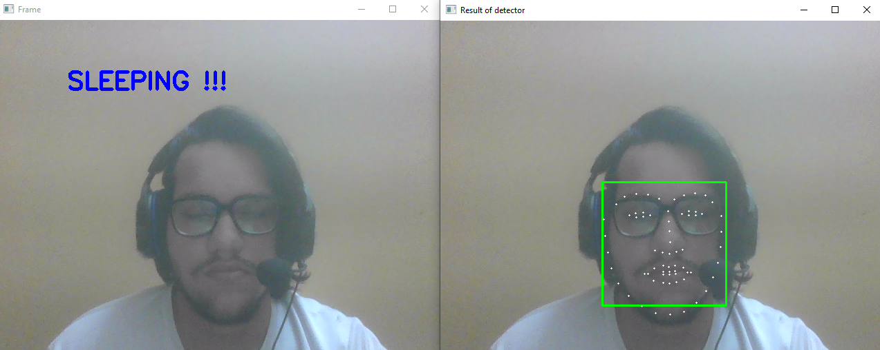

CONCLUSION

The Driver Drowsiness Detection System successfully uses computer vision and facial landmark analysis to monitor driver alertness in real time.

Key achievements:
- Detects eye blinking and closure accurately
- Classifies driver state into Active, Drowsy, and Sleeping
- Works in real-time using a simple webcam
- Provides visual feedback for safety

Future Improvements
- Add alarm/buzzer system when drowsy detected
- Integrate with IoT (Arduino/ESP32) for vehicle systems
- Improve accuracy using Deep Learning (CNN/LSTM)
- Deploy as a mobile or embedded system

